Tab 1

Full Transcription of Economics Study Notes
This document contains the word-for-word transcription of your handwritten economics notes, organized by topic and page.

Page 1: Economics Fundamentals
ECONOMICS!
Keywords:
- Goods & services - tangible source
- Supply & Demand
- Price & Quantity
- Equilibrium
- Market factors
Economics!
The study of scarcity & its implications for the consumption & production of goods & services, as well as on the transfer of wealth.
The significance of economics is that it enables you to understand the world around you.
- Understand people, business, markets, & governments & their interconnectedness.
- Understand why & how things change & how to respond to that change.
Demand comes before supply majority of the time apart from the times through marketing strategies to make consumers desire that.
Biggest problem $\rightarrow$ SCARCITY!
There are limited resources to satisfy the unlimited needs & wants of people.

Page 2: Market Basics
Therefore, people place a monetary value on the goods & services they need & want.
It also affects how private companies & government.
MARKET BASICS!
- A place, physical or virtual, where people go to buy & sell goods & services.
- 'Goods' & 'services' $\Rightarrow$ money exchanged 4 a product.
- Services - intangible things; work done, services rendered, advice.
  - * Money exchanged for skills.
In any market, there are two players:
- People who have a need/want for a good/service
  - - They are potential buyers, customers.
- People who are there to satisfy the need
  - - They are potential suppliers, sellers, service providers.
Can you connect this with supply & demand?
- Demand - created by the needs of people.
- Supply

Page 3: Law of Demand
LAW of DEMAND
Definition $\rightarrow$ The law of demand explains the inverse relationship btw the price of a good/service & the quantity demanded.
Meaning - the higher the price, the lower the quantity demanded and the vice versa.
$\uparrow P \rightarrow \downarrow Q_D$ $\Rightarrow$ Formula of Inverse Relation.
Factors influencing demand
Income (expendable income)
- People earn money & are willing to spend it on goods/services.
- * Expendable income - what is left after paying for basic needs.
- People with different incomes consider their expenses differently.
Price & Quantity
- People are willing to pay a certain amount for a good/service.
- Price too high $\Rightarrow$ people won't buy much, not many can afford.
- Price too low $\Rightarrow$ people want to buy more than what is available.

Page 4: Shifts in Demand
Shifts in Demand!
movement of the curve means the actual curve shifts left or right.
- Shift to the left: Demand ($Q$) decreases, $P$ stays the same.
- Shift to the right: Demand ($Q$) increases, $P$ stays the same.
Movement of the curve happens when there is a change in:
- Income
- Preferences
- Population
- Interest Rates
People earn $\uparrow \rightarrow$ products $\rightarrow \uparrow \rightarrow$ Spend more.
Preferences $\rightarrow$ trends & fashion ex.
$D_0 \rightarrow D_1 : \downarrow Q_D$
$D_0 \rightarrow D_2 : \uparrow Q_D$

Page 5: Law of Supply
Law of Supply:
Definition $\rightarrow$ The law of supply explains the direct relationship btw the price of a good service & the quantity supplied.
Meaning - the higher the price, the higher the quantity supplied, & vice versa the lower the price the lower the quantity supplied.
$\uparrow P \rightarrow \uparrow Q_S$
$\downarrow P \rightarrow \downarrow Q_S$
Factors that influence SUPPLY:
Factors of production
- Input Cost $\rightarrow$ Labour, land, capital, entrepreneurship.
- Labour - wages & salary of employees, other benefits.
- Land - rental 4 space, mortgages on properties.
- Capital - loans, investor's money, maintenance, to immovables (machinery/assets).
- Entrepreneurship - cost of human/intellectual capital.
Price of related goods
- If rival companies supply a similar product at a lower price.
- It will force you to reduce supply.
Technological Advancements
- Technology simplifies & speeds up production & service delivery.
- Therefore, $\uparrow$ supply $\rightarrow$ produce more at the same cost.

Page 6: Supply Curve & External Factors
Mother Nature
- Failed crops - immediate reduction in supply of food products.
- Dry mines - immediate reduction in supply of precious metals.
Monopoly - De Beers diamond $\rightarrow$ decide how much they're gonna make available.
* Supply is controlled by a single role player (exclusive & scarce).
THE SUPPLY CURVE
Always consider what changes first to determine effect.
If price is manipulated:
- There will be movement along the supply & demand curves.
- The curves will not shift.
- The effect will be on both quantity demanded & supplied.
Shifts in Supply:
- movement of the curve means the actual curve shifts left or right.
- Shift to the left: Supply ($Q$) decreases; $P$ stays the same.
- Shift to the right: Supply ($Q$) increases; $P$ stays the same.
movement of the curve happens when there is a change in:
- Cost of Production
- Tech
- Expectations - customer/consumer
- Number of firms in the market
- Taxes & Subsidies

Page 7: Production & Markets
Cost of Production
- If the cost of any of the factors of production $\uparrow$, the total cost of production increases.
- If the cost of production increases, less products can be produced.
- Therefore, supply will decrease & the curve shifts to the left.
* An Indirect relationship. $\uparrow COP \rightarrow \downarrow Q_S$
Expectations $\uparrow$ then the customers will buy less because which means that the demand will go down eventually pulling the quantity of supply down as well (opposite) Demand $\downarrow$ $Q_S \downarrow$.
If the organizations produce more of the same product then the demand would decrease as the products are more available. This would cause the total cost of production to increase leading the supply to eventually decrease (opposite) More people make the same good (quantity supply $\uparrow$).
Taxes & Subsidies
- If taxes are added to the cost of production then the production cost increases since you will need money to pay off the tax. Meaning the price will also go up leading the demand to go down which eventually cause companies will lower labor costs etc. Then supply decreases.
- Subsidies are granted to essential markets similar to agriculture & housing. Subsidies keep the line stagnant.
- Direct Taxes doesn't affect supply as its mostly extended to demand.

Page 8: Market Equilibrium
MARKET EQUILIBRIUM!
Definition $\Rightarrow$ A state of balance btw supply & demand.
- Graphically $\Rightarrow$ where supply & demand curves cross.
- Importance $\Rightarrow$ Tells us where consumers & producers are willing to meet in terms of price & quantity.
* Consumers know what they will pay & how much will be available.
* Producers know how much will sell at what price it will be bought.
$Q_E : Q_S = Q_D$

Page 9: Inflation
INFLATION!
A general increase in prices of products due to economical crisis.
- fall in the purchasing power of money.
- Why is there a gradual $\uparrow$ in price?
  - Natural increase in demand.
  - Population.
Money (currency) has intrinsic value. $100k \rightarrow 100k$. The true measure of the value of currency is what can be bought with it. Therefore, over time, price increase & purchasing power of money becomes relatively less over time.
Example: $100k$ in $2020 = 110k$ in $2024$.
Example country $\rightarrow$ Zimbabwe.
Person A could buy everyday items for $100k$ in $2020$. Person A in $2024$ would need $110k$ to buy the same 5 items.
- If Person A only has $100k$ available in $2024 \rightarrow$ poor.
- If Person A has exactly $110k$ available in $2024 \rightarrow$ same.
- If Person A has more than $110k$ available in $2024 \rightarrow$ wealthy.

Page 10: Economics & Central Banks
1) How can inflation be a good thing?
Inflation is a good thing because it means that the economy is growing because it means residents can afford more hence the prices have to be raised to profit more. More demand $\rightarrow$ Higher prices.
2) What is a central bank & what is its role in the economy?
Bank of Banks $\rightarrow$ Run by the govnt and ensure prices don't fluctuate too much. Spend money in a certain way to help business.
Low interest stimulates business to grow.
If the interest rates are lower, then people will have more money to spend. However eventually it will cause inflation as the demand will increase and the value of the money will decrease as the amount of things you can buy with that will reduce.
Higher interest rates!
Recession is a economic depression causing the GDP to fall as businesses success rate reduce and unemployment rates increase. THIS eventually causes the interest rates to decrease.
Recession happens because customers begin to spend less and business investments fall, imports less, could also be because of High Inflation. Ex: War & Covid. Export $\rightarrow$ less.

Page 11: Case Studies
Middle East Conflict Oil Market
- Iran borders the Strait of Hormuz through which $20\%$ of global oil supply flows.
- Therefore once the strait was blocked as a direct result of the conflict, supply in oil $\downarrow$ rapidly causing a sharp $\uparrow$ in price.
- As a secondary effect many countries are worried about running out of oil as they are depleting their reserves which means they are seeking to buy more oil $\rightarrow$ demand $\uparrow$ for oil.
Corn Industry Failure
- Because the crop farming industries are failing, meaning they're supply is lower leading to reduce the demand as it doesn't satisfy the people's demands. This eventually results in increasing demand for the US corn farming industry. Heavy demand causes the price to increase which means the Aust corn farming industry will be more profitable in this scenario. This would also be increase the cost of production which increase for the US corn.
Role of the Govnt
- Govnt influences markets through: Central Bank (interest rates, stimulus package, subsidies).
- Laws & Budgets $\rightarrow$ expectations.
- Price Ceilings: Govnt-imposed max price that the producers can charge 4 a product. Usually manipulated by the government for medicine, oil, essential goods (petrol), Rental market.
- To prevent producers from taking advantage of the desperate consumers.
- $\downarrow$ price $\rightarrow$ $\uparrow$ demand & $\downarrow$ supply $\Rightarrow$ shortage. Consumers miss out. Subsidies $\rightarrow$ price ceilings.

3. Scenario: Decrease in Supply (Shift Left)
- Real-time Example: Electricity prices in Sweden rise, increasing the Cost of Production (COP) for factories like Northvolt.
- Graph: The original Supply curve ($S_1$) moves to the left ($S_2$).
- Result: Equilibrium Price increases (inflation), but Quantity decreases.

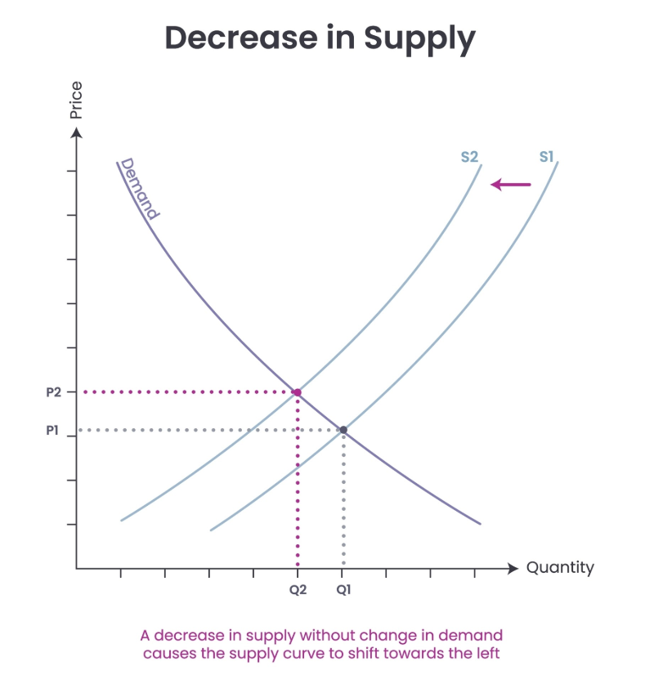

Tab 2

IB Grade 9 Economics: Comprehensive Guide with Graphs and Real-World Examples
This document combines the core economic theories from your notes with detailed graphical scenarios and real-time examples specifically relevant to Sweden and the global market.

1. The Law of Demand: Inverse Relationship
Theory: As the price of a good or service increases, the quantity demanded by consumers decreases ($\uparrow P \rightarrow \downarrow Q_D$).
- Product Example (Tangible): If the price of Oatly milk in ICA increases from 20 SEK to 35 SEK, many Swedish consumers will switch to cheaper store-brand alternatives, causing a movement up the demand curve.
- Service Example (Intangible): If Spotify raises its monthly Premium subscription fee significantly, some users may cancel their service or move to the free tier.
The Graph: A downward-sloping line. A change in price causes a movement along this line.

2. The Law of Supply: Direct Relationship
Theory: As the price of a good or service increases, producers are willing to supply more of it to the market to increase profits ($\uparrow P \rightarrow \uparrow Q_S$).
- Product Example: If the global price of timber increases, Swedish forestry companies like Sveaskog will increase logging operations to sell more wood while it is highly profitable.
- Service Example: If the hourly rate for private tutors in Stockholm rises, more university students will be motivated to offer their tutoring services to the market.
The Graph: An upward-sloping line. A change in price causes a movement along this line.

3. Market Equilibrium and Disequilibrium
Theory: Equilibrium is the state where the quantity demanded by consumers exactly matches the quantity supplied by producers ($Q_D = Q_S$).
- Real-Time Example (Equilibrium): The daily price of electricity on the Nord Pool exchange. The price fluctuates until the amount of power generated matches the amount Swedish homes and factories need.
- Disequilibrium (Shortage): This occurs when the price is too low. In the Swedish Housing Market, rent control (a price ceiling) often keeps prices below equilibrium, resulting in long queues (shortages) for apartments in cities like Stockholm.
The Graph: An 'X' shape where the supply and demand curves intersect. The crossing point identifies the Equilibrium Price and Quantity.

4. Shifting the Demand Curve (Non-Price Factors)
A shift occurs when a factor other than price changes, such as income, preferences, or interest rates.
- Scenario (Shift Right): The Swedish government announces a tax cut, increasing the expendable income of households. Demand for "luxury" products like iPhone 15s shifts to the right.
- Scenario (Shift Left): The Riksbank (Central Bank) raises interest rates. It becomes more expensive to borrow money for a car loan. Consequently, the demand for Volvo cars shifts to the left.
The Graph: The entire demand curve moves right (increase) or left (decrease).

5. Shifting the Supply Curve (Non-Price Factors)
A shift occurs when production costs, technology, or external factors like "Mother Nature" change.
- Scenario (Shift Left): Electricity prices for factories rise sharply. For a company like Northvolt (battery producer), this increases the Cost of Production (COP). Their supply curve shifts to the left.
- Scenario (Shift Right): A technological breakthrough allows H&M to automate their textile recycling process, making it cheaper to produce "green" clothing. Supply shifts to the right.
The Graph: The entire supply curve moves right (increase) or left (decrease).

6. Global Case Study: Cobalt and Interest Rates
- The Event: Political instability in the DRC (Democratic Republic of Congo).
- Impact on Supply: Cobalt is a key raw material for EV batteries. Unrest causes a Shift Left in the global supply of cobalt.
- Impact on Product: The price of electric vehicles in Sweden rises because the Input Cost for manufacturers has increased.
- Central Bank Response: If this causes widespread inflation, the Riksbank may raise interest rates to reduce overall demand in the economy.

Graphs

- 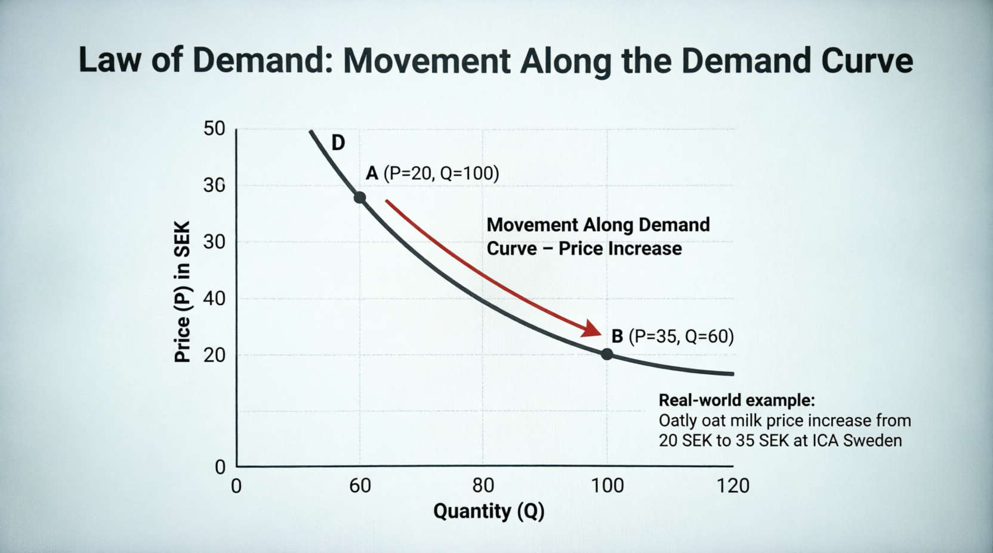
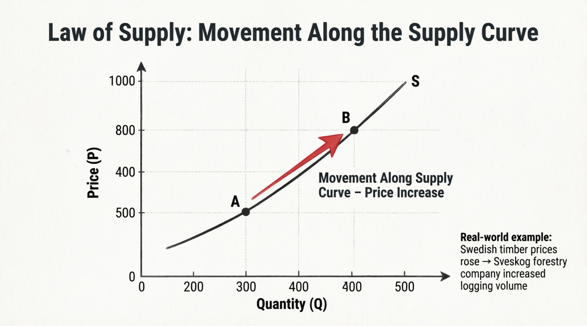
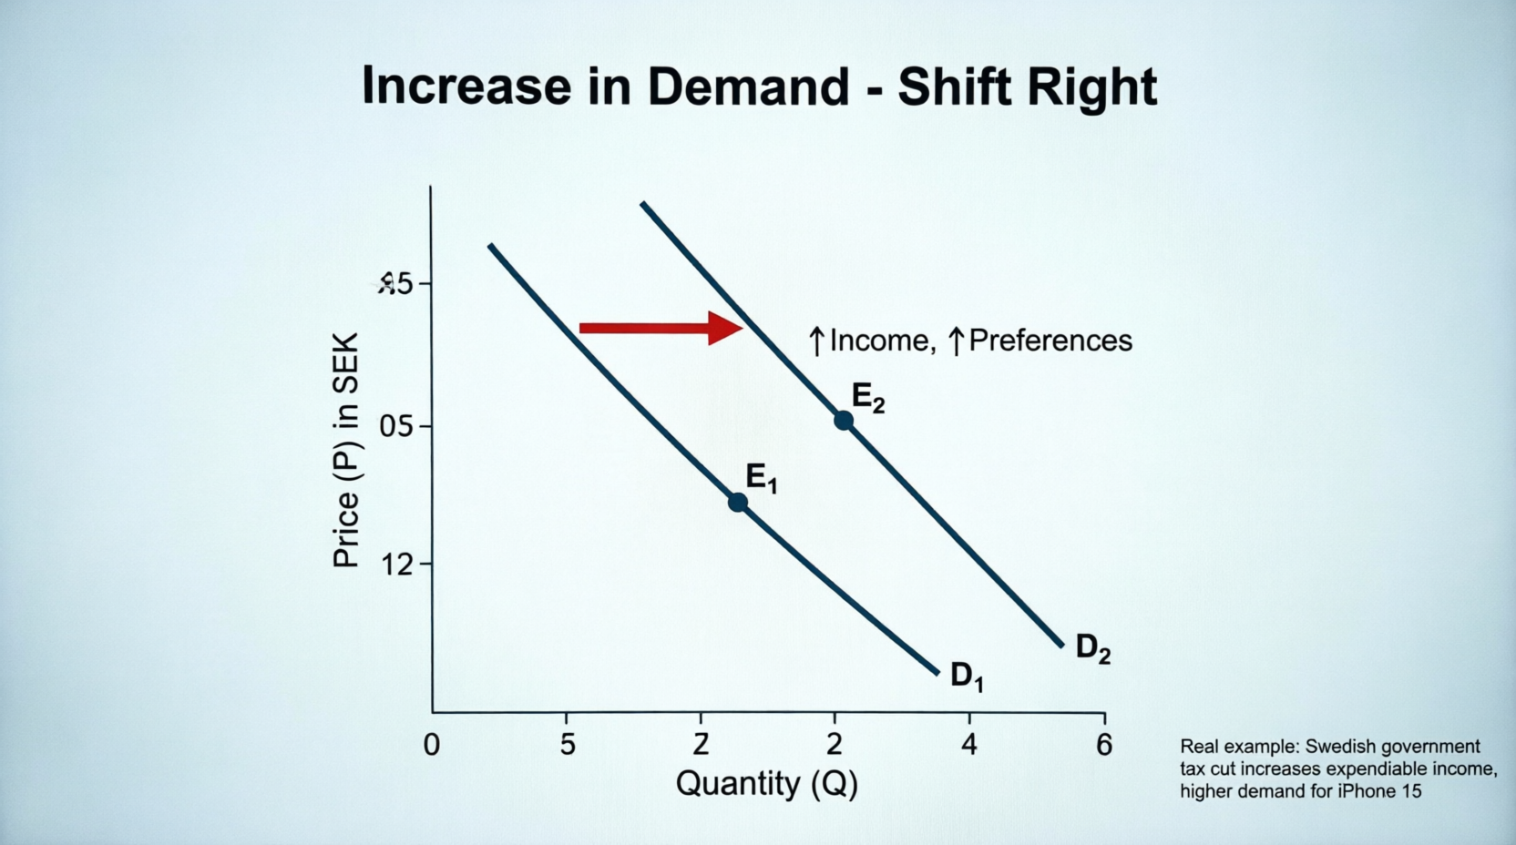
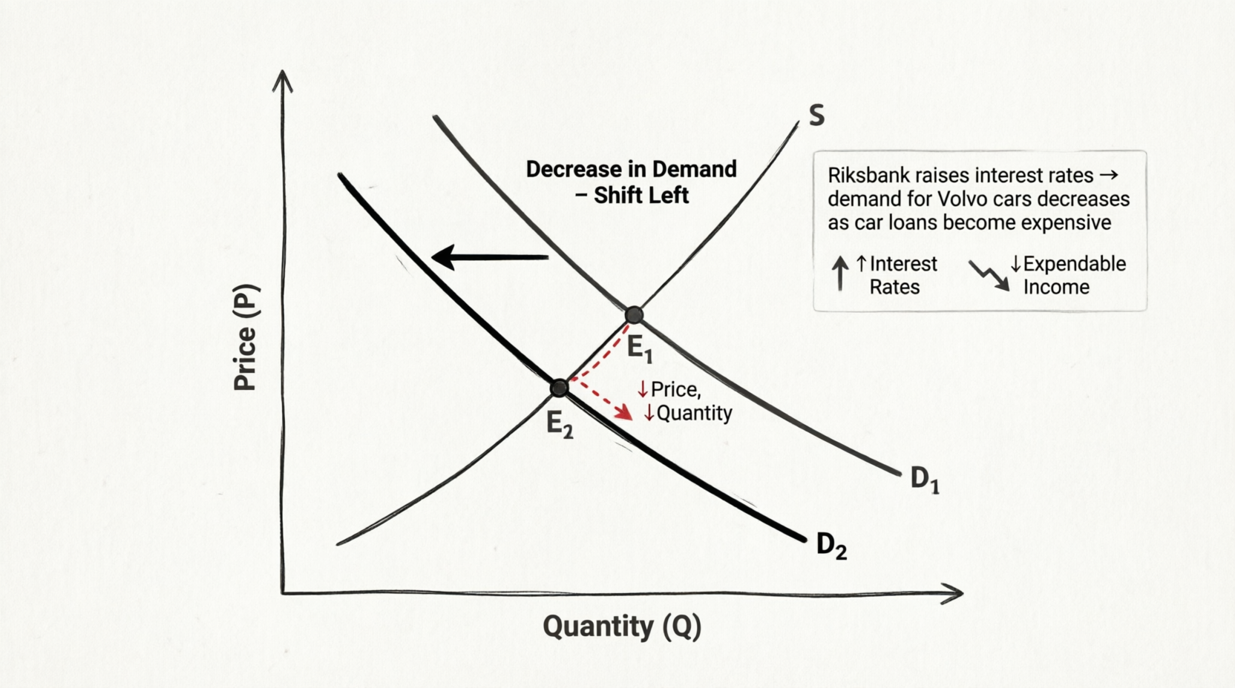
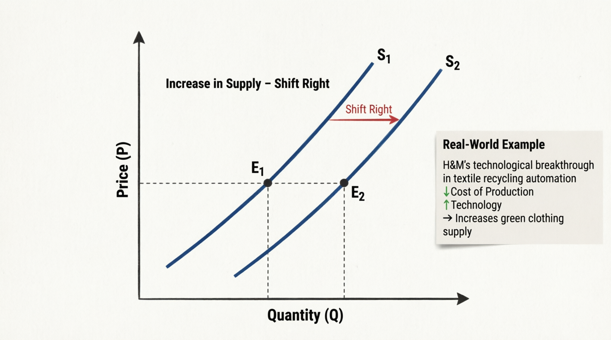
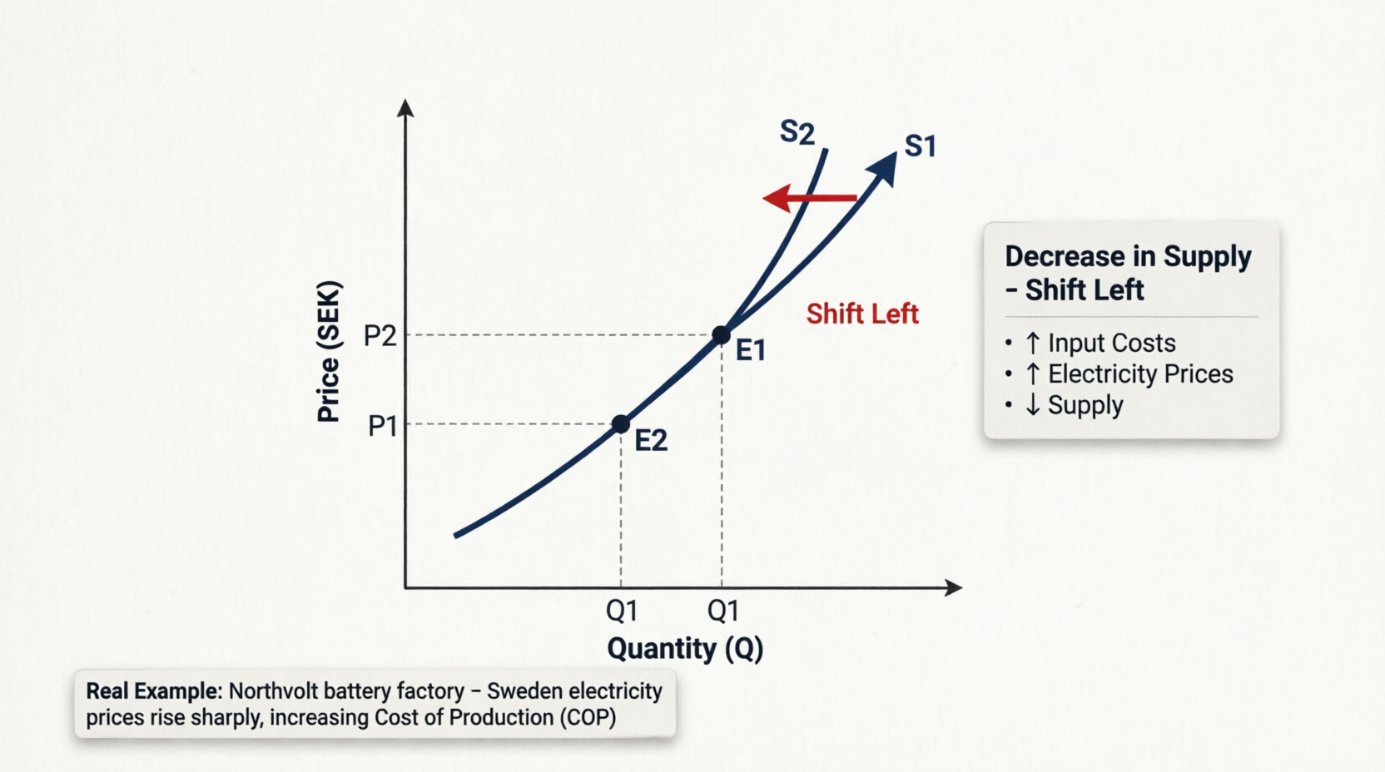
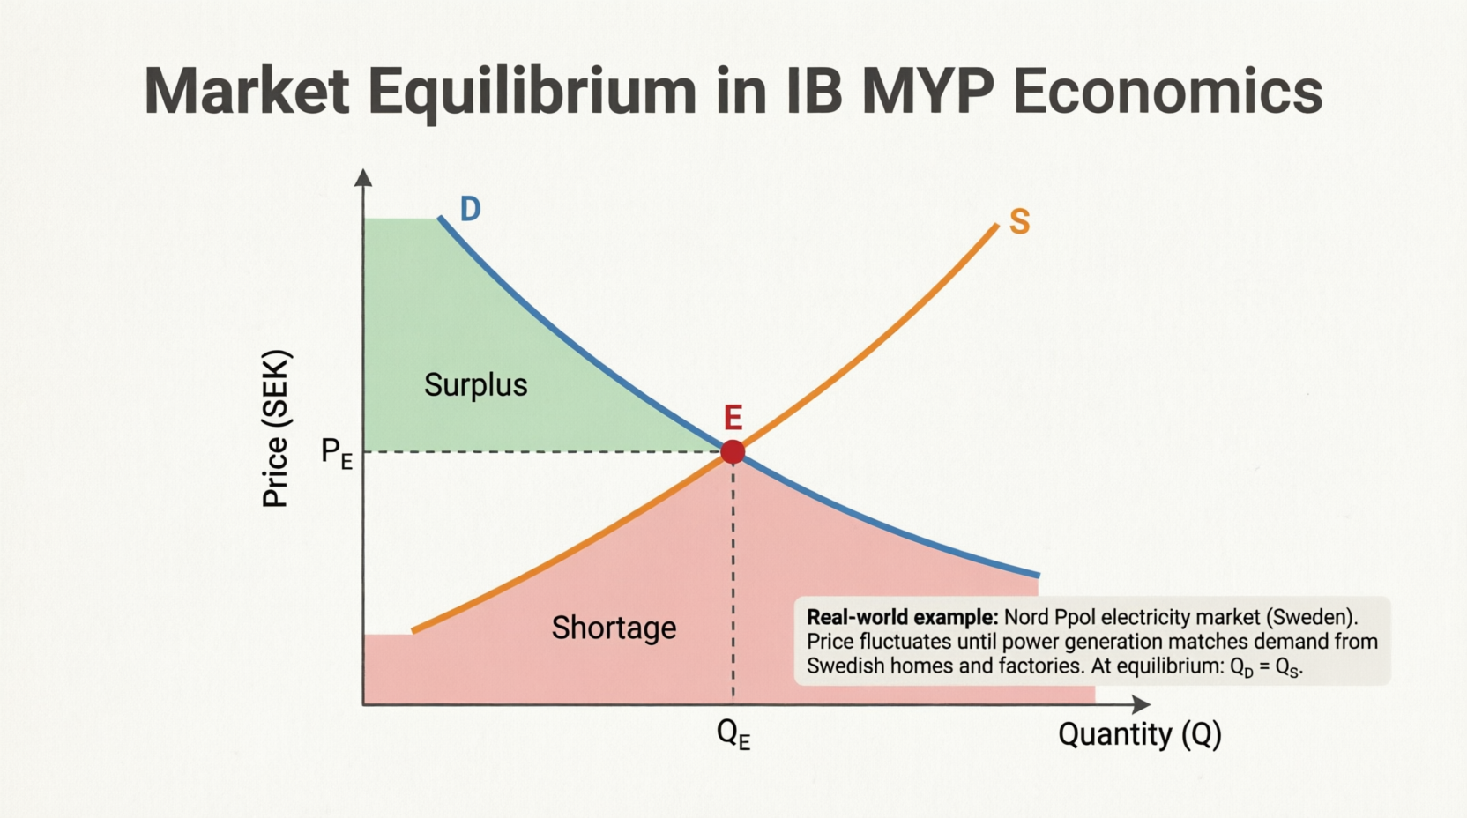
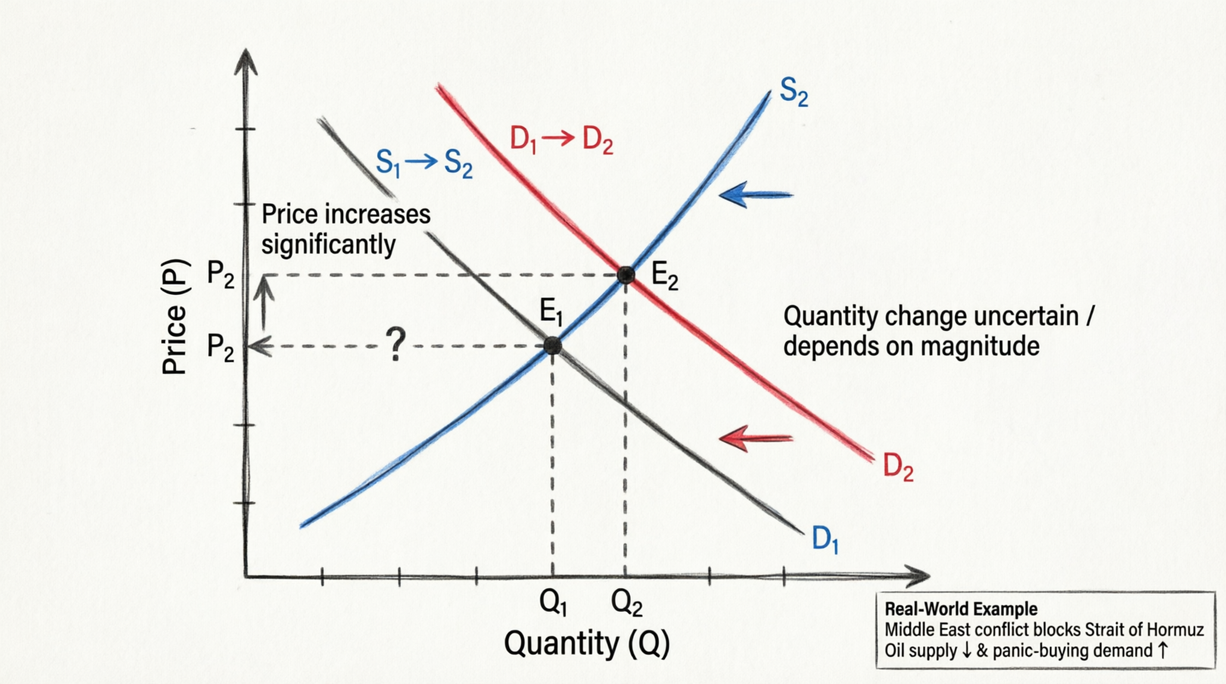
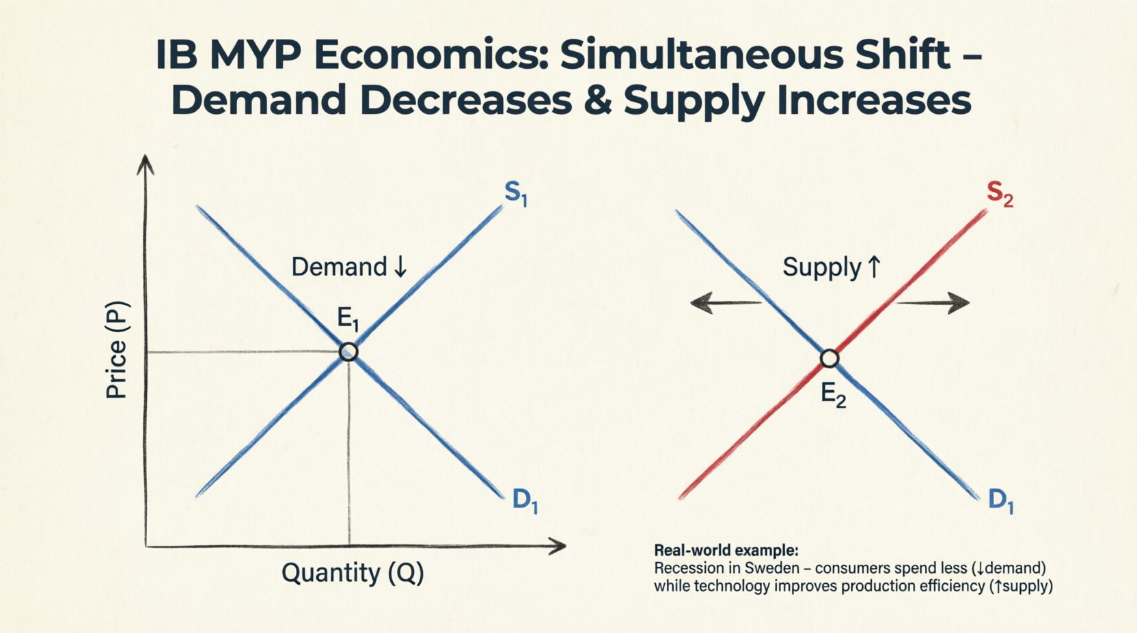

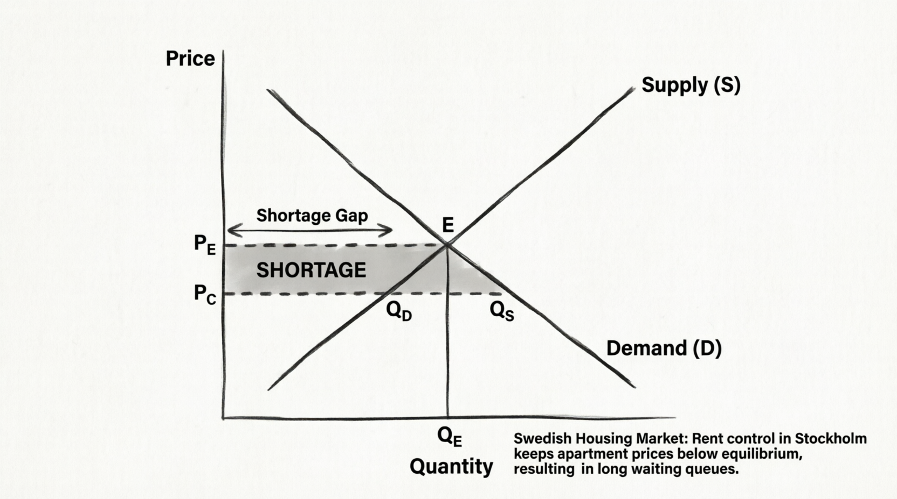
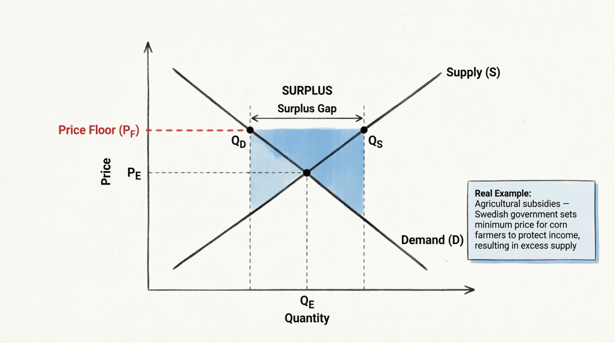
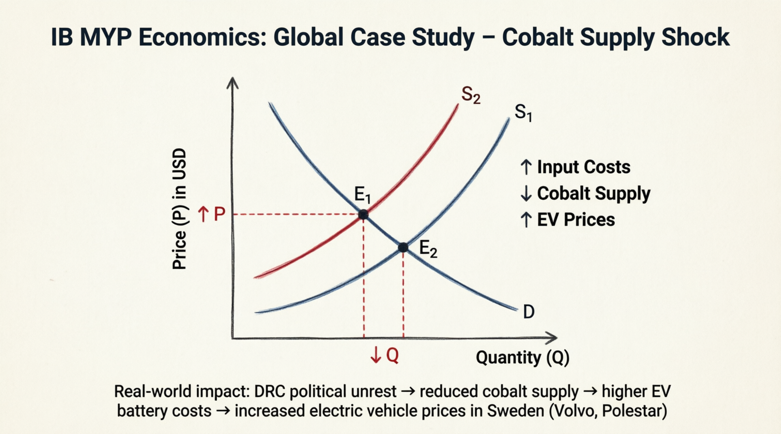
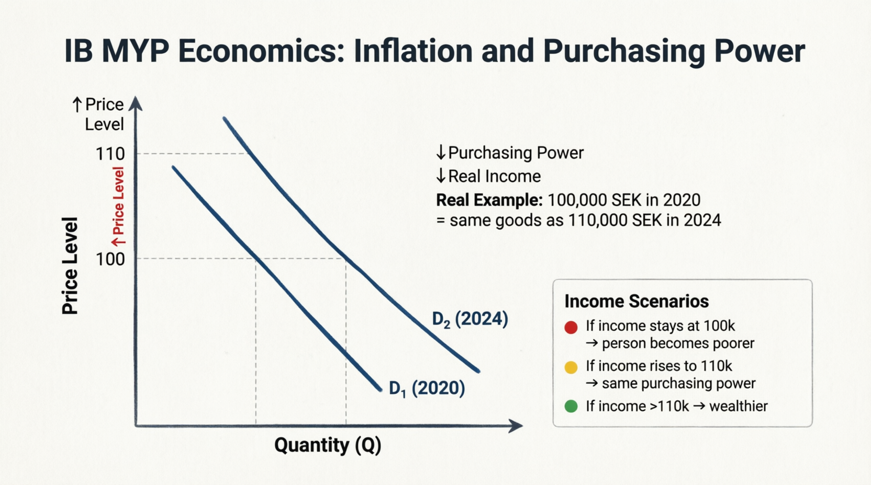
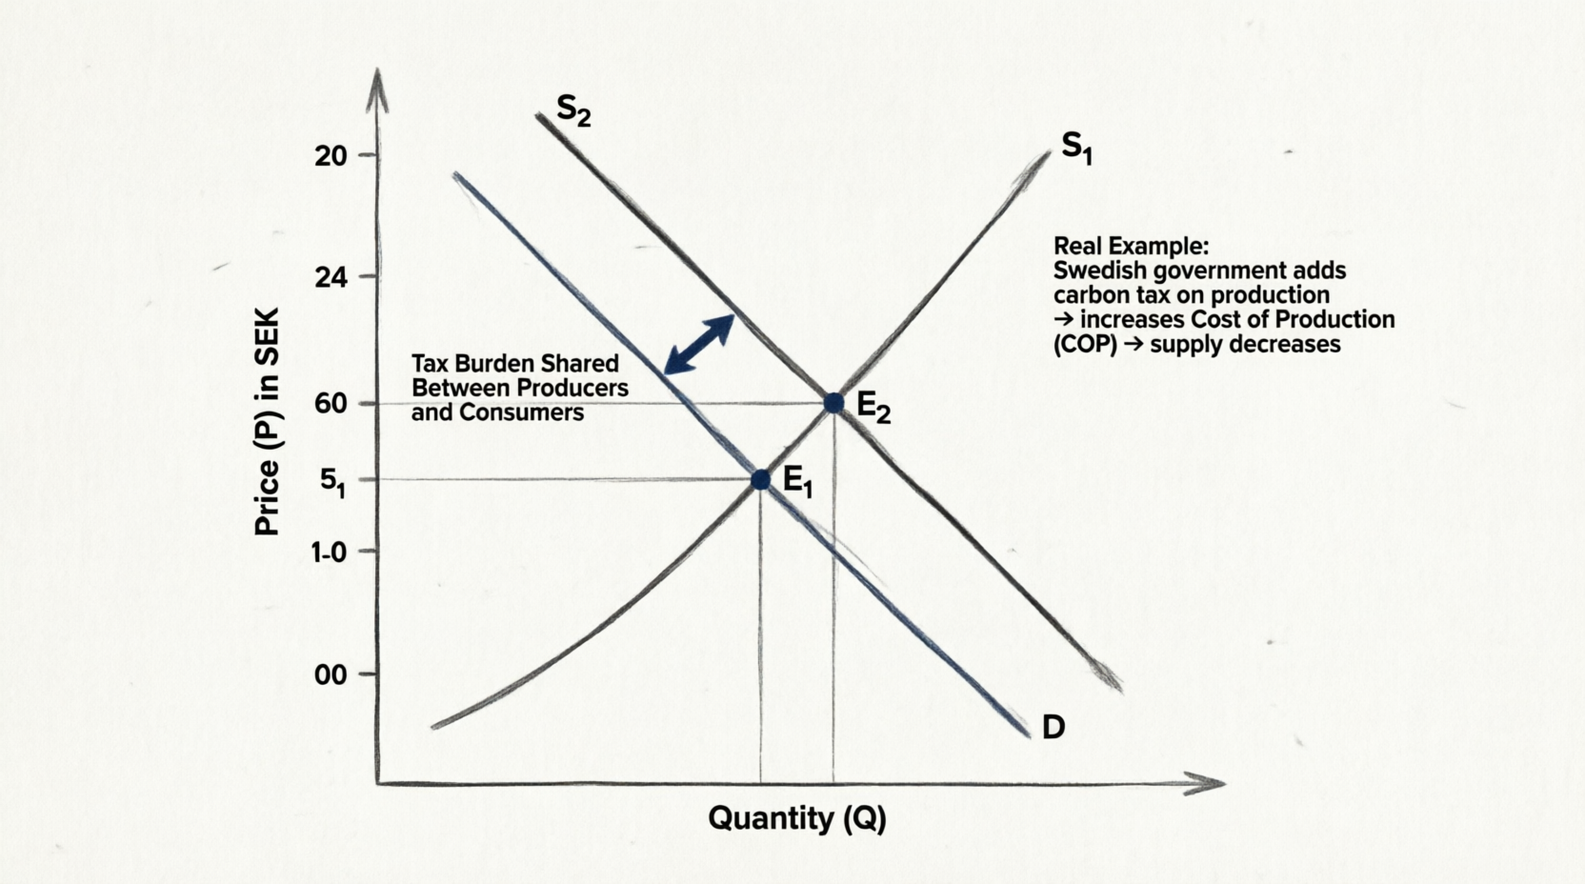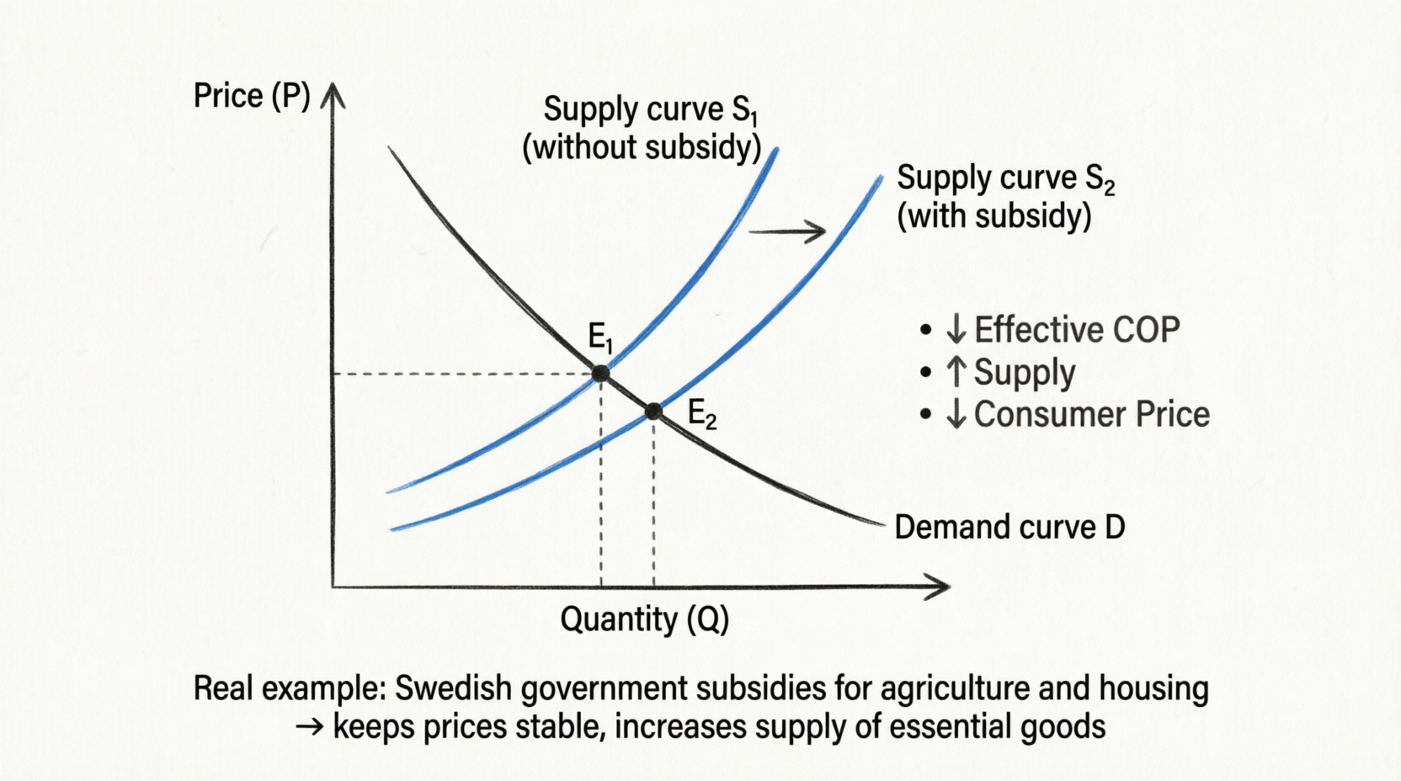
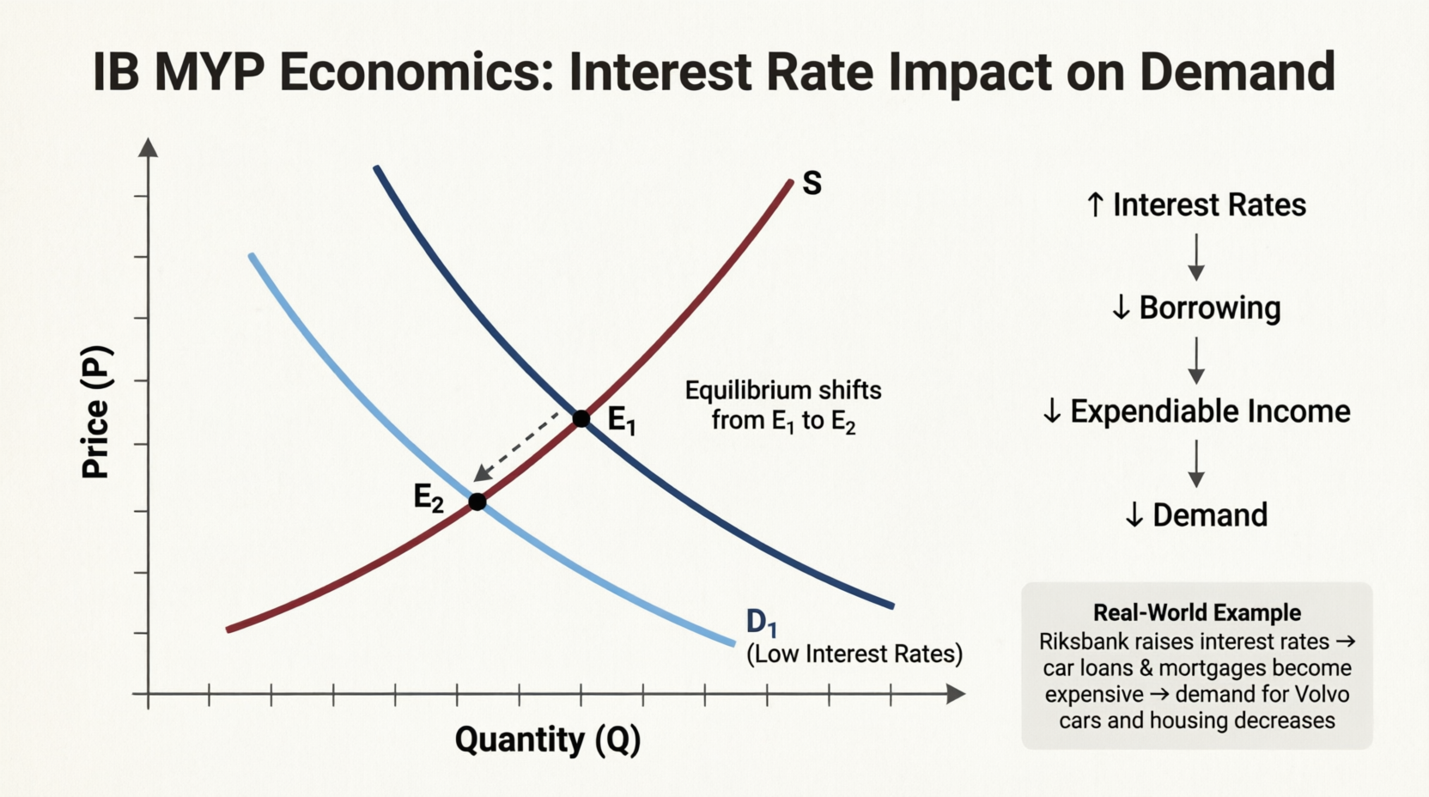

Concepts

SLIDE 1: TITLE SLIDE
IB MYP Economics: Supply and Demand
- Grade 9 Comprehensive Guide
- Real-World Examples from Sweden & Global Markets
- Following IB MYP International Standards

SLIDE 2: ECONOMICS FUNDAMENTALS
What is Economics?
- The study of scarcity & its implications for consumption & production
- Enables understanding of people, businesses, markets & governments
Key Concepts:
- Goods & Services (tangible & intangible)
- Supply & Demand
- Price & Quantity
- Equilibrium
- Market Factors
The Biggest Problem: SCARCITY
- Limited resources to satisfy unlimited needs & wants

SLIDE 3: MARKET BASICS
What is a Market?
- Physical or virtual place where buying & selling occurs
- Goods & Services exchanged for money
Two Key Players:
- Buyers/Demanders - People with needs/wants
- Sellers/Suppliers - People satisfying those needs
Connection to Supply & Demand:
- Demand = Created by people's needs
- Supply = Response to satisfy those needs

SLIDE 4: LAW OF DEMAND
Definition: The inverse relationship between price and quantity demanded
Formula: ↑P → ↓QD
Key Points:
- Higher price = Lower quantity demanded
- Lower price = Higher quantity demanded
Factors Influencing Demand:
- Income (expendable income)
- Price & Quantity relationship
- Consumer affordability
[GRAPH 1: Law of Demand - Movement Along Curve]
Real Example: Oatly milk price increase from 20 SEK to 35 SEK at ICA Sweden

SLIDE 5: SHIFTS IN DEMAND
Movement vs. Shift:
- Movement = Price change (along the curve)
- Shift = Non-price factor change (entire curve moves)
Demand Shifts Right (Increase):
- ↑ Income
- ↑ Preferences (trends & fashion)
- ↑ Population
- ↓ Interest Rates
Demand Shifts Left (Decrease):
- ↓ Income
- ↓ Preferences
- ↓ Population
- ↑ Interest Rates
[GRAPH 2: Increase in Demand - Shift Right]

Real Example: Swedish tax cut → higher iPhone 15 demand

[GRAPH 3: Decrease in Demand - Shift Left]
Real Example: Riksbank raises rates → Volvo car demand decreases

SLIDE 6: LAW OF SUPPLY
Definition: The direct relationship between price and quantity supplied
Formulas:
- ↑P → ↑QS
- ↓P → ↓QS
Key Points:
- Higher price = Higher quantity supplied (more profit)
- Lower price = Lower quantity supplied
[GRAPH 4: Law of Supply - Movement Along Curve]
Real Example: Swedish timber prices rise → Sveaskog increases logging

SLIDE 7: FACTORS INFLUENCING SUPPLY
Factors of Production (Input Costs):
- Labour - Wages & salaries
- Land - Rental & mortgages
- Capital - Loans, machinery, maintenance
- Entrepreneurship - Human/intellectual capital
Other Factors:
- Price of related goods (competition)
- Technological advancements (↑ supply)
- Mother Nature (disasters reduce supply)
- Monopoly control (supply manipulation)

SLIDE 8: SHIFTS IN SUPPLY
Supply Shifts Right (Increase):
- ↓ Cost of Production
- ↑ Technology
- ↑ Number of firms
- ↑ Subsidies
- ↓ Taxes
Supply Shifts Left (Decrease):
- ↑ Cost of Production
- ↓ Technology
- ↓ Number of firms
- ↑ Taxes
- ↓ Subsidies
- Negative expectations
[GRAPH 5: Increase in Supply - Shift Right]
Real Example: H&M automation → green clothing supply increases
[GRAPH 6: Decrease in Supply - Shift Left]
Real Example: Northvolt - electricity prices rise → supply decreases

SLIDE 9: COST OF PRODUCTION
Relationship: ↑COP → ↓QS (Indirect/Inverse)
Why?
- Higher production costs = Less can be produced
- Supply curve shifts LEFT
Examples:
- Rising wages → Higher costs → Lower supply
- Expensive raw materials → Reduced production
- Higher electricity prices → Factory output decreases

SLIDE 10: TAXES & SUBSIDIES
Taxes:
- Increase cost of production
- Shift supply curve LEFT
- Reduce supply
- Example: Carbon tax on Swedish manufacturers
Subsidies:
- Decrease effective cost of production
- Shift supply curve RIGHT
- Increase supply
- Keep prices stable for essential goods
- Example: Swedish agriculture & housing subsidies
Note: Direct taxes mostly affect demand, not supply

SLIDE 11: MARKET EQUILIBRIUM
Definition: Balance between supply and demand
Key Formula: QE : QS = QD
Importance:
- Consumers know what to pay & availability
- Producers know sales volume & price
Graphically: Where supply & demand curves intersect
[GRAPH 7: Market Equilibrium]
Real Example: Nord Pool electricity market - price fluctuates until generation matches demand
Disequilibrium:
- Surplus: Price too high (QS > QD)
- Shortage: Price too low (QD > QS)

SLIDE 12: INFLATION
Definition: General increase in prices due to economic crisis
Effects:
- Fall in purchasing power of money
- ↓ Real income value
Why Prices Gradually Increase:
- Natural increase in demand
- Population growth
Real Example:
- 100,000 SEK in 2020 = 110,000 SEK in 2024 (same goods)
[GRAPH 8: Inflation & Purchasing Power]
Three scenarios showing wealth changes with inflation

SLIDE 13: INFLATION - IS IT GOOD?
When Inflation is Positive:
- Indicates economic growth
- Residents can afford more
- Higher demand → Higher prices → More profit
When Inflation is Negative:
- Erodes purchasing power
- Hurts fixed-income earners
- Creates uncertainty
Extreme Example: Zimbabwe hyperinflation

SLIDE 14: CENTRAL BANKS & INTEREST RATES
What is a Central Bank?
- "Bank of Banks" (Riksbank in Sweden)
- Run by government
- Stabilizes prices & economy
Low Interest Rates:
- ↑ Borrowing
- ↑ Business growth
- ↑ Consumer spending
- Risk: Can cause inflation
High Interest Rates:
- ↓ Borrowing
- ↓ Consumer spending
- Used to combat inflation
- Can lead to recession if too high
[GRAPH 9: Interest Rate Impact on Demand]
Riksbank raises rates → Volvo & housing demand decreases

SLIDE 15: RECESSION
Definition: Economic depression with falling GDP
Characteristics:
- ↓ Business success rates
- ↑ Unemployment
- ↓ Consumer spending
- ↓ Business investments
- ↓ Imports & Exports
Causes:
- High inflation
- War (e.g., Middle East conflict)
- Pandemics (e.g., COVID-19)
- High interest rates
Response: Central bank decreases interest rates

SLIDE 16: SIMULTANEOUS SHIFTS
When Both Curves Move:
Scenario 1: Demand ↑ + Supply ↓
- Price: Increases significantly
- Quantity: Uncertain (depends on magnitude)
[GRAPH 10: Demand Up + Supply Down]
Real Example: Middle East conflict blocks Strait of Hormuz → Oil supply ↓ + Panic demand ↑
Scenario 2: Demand ↓ + Supply ↑
- Price: Decreases
- Quantity: Uncertain
[GRAPH 11: Demand Down + Supply Up]
Real Example: Swedish recession + Technology improvement

SLIDE 17: BOTH CURVES INCREASE
Demand ↑ + Supply ↑
Effects:
- Quantity: Definitely increases
- Price: Uncertain (depends on which shift is larger)
[GRAPH 12: Both Demand & Supply Increase]
Real Example: Swedish tech sector boom - population growth ↑ demand; automation ↑ production

SLIDE 18: BOTH CURVES DECREASE
Demand ↓ + Supply ↓
Effects:
- Quantity: Definitely decreases
- Price: Uncertain (depends on magnitude)
[GRAPH 13: Both Demand & Supply Decrease]
Real Example: COVID-19 pandemic - lockdown ↓ demand; supply chain disruptions ↓ production

SLIDE 19: PRICE CEILING
Definition: Government-imposed maximum price
Purpose:
- Protect consumers from high prices
- Applied to essential goods (medicine, petrol, rent)
Effect:
- Price set BELOW equilibrium
- ↑ Demand + ↓ Supply = SHORTAGE
[GRAPH 14: Price Ceiling & Shortage]
Real Example: Stockholm rent control → Long waiting queues for apartments
Consequences:
- Consumers miss out
- Black markets may develop
- Quality may decrease

SLIDE 20: PRICE FLOOR
Definition: Government-imposed minimum price
Purpose:
- Protect producers/farmers
- Ensure fair income
Effect:
- Price set ABOVE equilibrium
- ↓ Demand + ↑ Supply = SURPLUS
[GRAPH 15: Price Floor & Surplus]
Real Example: Swedish agricultural subsidies → Minimum corn price → Excess supply
Consequences:
- Government must buy surplus
- Wasted resources
- Higher prices for consumers

SLIDE 21: TAX IMPACT ON SUPPLY
How Taxes Affect Supply:
- ↑ Cost of Production
- Supply curve shifts LEFT
- ↑ Equilibrium price
- ↓ Equilibrium quantity
Tax Burden:
- Shared between producers & consumers
- Depends on elasticity
[GRAPH 16: Tax Impact]
Real Example: Swedish carbon tax → Manufacturing costs increase → Supply decreases

SLIDE 22: SUBSIDY IMPACT ON SUPPLY
How Subsidies Affect Supply:
- ↓ Effective Cost of Production
- Supply curve shifts RIGHT
- ↓ Consumer price
- ↑ Quantity supplied
Purpose:
- Keep essential goods affordable
- Support strategic industries
[GRAPH 17: Subsidy Impact]
Real Example: Swedish agriculture & housing subsidies → Stable prices, increased supply

SLIDE 23: GLOBAL CASE STUDY - COBALT
The Event: Political instability in Democratic Republic of Congo (DRC)
Impact Chain:
- DRC unrest → Cobalt supply ↓
- Cobalt is key for EV batteries
- Input costs for battery makers ↑
- Electric vehicle prices ↑
[GRAPH 18: Cobalt Supply Shock]
Real Impact: Higher EV prices in Sweden (Volvo, Polestar)
Lesson: Global supply chains are interconnected

SLIDE 24: KEY FORMULAS SUMMARY
Demand:
- Law of Demand: ↑P → ↓QD
- Demand Shift Right: ↑Income, ↑Preferences, ↑Population
- Demand Shift Left: ↓Income, ↓Preferences, ↑Interest Rates
Supply:
- Law of Supply: ↑P → ↑QS
- Supply Shift Right: ↓COP, ↑Technology, ↑Subsidies
- Supply Shift Left: ↑COP, ↓Technology, ↑Taxes
Equilibrium:
- QE: QD = QS
- Shortage: QD > QS
- Surplus: QS > QD

SLIDE 25: IB MYP ASSESSMENT CRITERIA
Criterion A: Knowing & Understanding
- Economic theories & terminology
- Graph interpretation
Criterion B: Investigating
- Real-world case studies
- Data analysis
Criterion C: Communicating
- Clear graph labeling
- Proper economic terminology
Criterion D: Thinking Critically
- Analysis of market interventions
- Evaluation of policies

SLIDE 26: STUDY TIPS
For Graphs:
- Always label completely (Title, Axes, Curves, Points)
- Use arrows to show direction of change
- Mark equilibrium points (E1, E2)
- Show price & quantity changes with dashed lines
For Analysis:
- Identify what changes first (price vs. non-price factor)
- Determine if it's movement or shift
- Analyze which curve shifts & direction
- Find new equilibrium
- Compare old vs. new P & Q
For Real Examples:
- Swedish companies: Volvo, H&M, Northvolt, Oatly, Spotify
- Swedish institutions: Riksbank, ICA, Nord Pool
- Global events: DRC cobalt, Middle East oil, COVID-19

SLIDE 27: REAL-WORLD CASE STUDIES
Swedish Examples:
- Northvolt - Electricity price shock (Supply ↓)
- Stockholm Housing - Rent control (Price Ceiling → Shortage)
- H&M - Automation technology (Supply ↑)
- Volvo - Interest rate impact (Demand ↓)
- Sveaskog - Timber prices (Movement along supply)
- Oatly - Price changes (Movement along demand)
Global Examples:
- Middle East Conflict - Strait of Hormuz oil blockade
- DRC Cobalt Crisis - EV battery costs
- COVID-19 Pandemic - Global supply chain disruption
- Zimbabwe - Hyperinflation case study

SLIDE 28: KEY TAKEAWAYS
- Scarcity is the fundamental economic problem
- Demand slopes downward (inverse relationship)
- Supply slopes upward (direct relationship)
- Price changes cause movement ALONG curves
- Non-price factors cause curves to SHIFT
- Equilibrium is where markets clear (QD = QS)
- Government intervention creates shortages or surpluses
- Simultaneous shifts create uncertain outcomes
- Real-world examples connect theory to practice
- Global events impact local markets

SLIDE 29: PRACTICE QUESTIONS
- If Swedish income taxes decrease, what happens to demand for IKEA furniture?
- How would a drought affecting Swedish wheat crops impact bread prices?
- Explain why the Riksbank might raise interest rates during high inflation
- What happens to the housing market if rent control is removed?
- Analyze the impact of a new technology that reduces battery production costs

SLIDE 30: THANK YOU
Questions?
Remember:
- Economics helps you understand the world
- Practice drawing graphs daily
- Connect theory to real-life examples
- Think critically about cause & effect
Good luck with your IB MYP Economics!

PRESENTATION COMPLETE!
All 18 graphs have been generated following IB MYP international standards with:
✅ Proper labeling (axes, curves, equilibrium points)
✅ Real-world Swedish & global examples
✅ Clear arrows showing direction of change
✅ Professional academic style
✅ Grid backgrounds for precision

Tab 3

SLIDE 1: TITLE SLIDE
- ECONOMICS: SUPPLY & DEMAND
IB MYP Grade 9 Economics
Key Topics:
- Law of Demand & Supply
- Market Equilibrium
- Curve Shifts
- Government Intervention
- Real-World Case Studies

SLIDE 2: ECONOMICS FUNDAMENTALS
What is Economics?
- The study of scarcity and its implications for consumption & production
- Understanding the world around us
- Key Concepts:
- ✓ Goods & Services (tangible & intangible)
- ✓ Supply & Demand
- ✓ Price & Quantity
- ✓ Equilibrium
✓ Market Factors
The Biggest Problem: SCARCITY
Limited resources to satisfy unlimited needs & wants

SLIDE 3: MARKET BASICS
What is a Market?
- Physical or virtual place where buying & selling occurs
- Money exchanged for products
Two Key Players:
- Buyers/Demanders - People with needs/wants
- Sellers/Suppliers - People who satisfy those needs
Connection to Supply & Demand:
- Demand = Created by people's needs
- Supply = Satisfaction of those needs

SLIDE 4: LAW OF DEMAND
- Definition:
The inverse relationship between price and quantity demanded
- Formula:

↑P→↓QD
↑P→↓Q
D
​

↓P→↑QD
↓P→↑Q
D
​
Meaning:
- Higher price → Lower quantity demanded
- Lower price → Higher quantity demanded
- Real-World Example:
Oatly milk price increases from 20 SEK to 35 SEK at ICA Sweden → Consumers buy less

assessment

IB MYP ECONOMICS: SUPPLY & DEMAND

COMPREHENSIVE MOCK TEST - 20 QUESTIONS

SECTION A: MULTIPLE CHOICE QUESTIONS (Questions 1-5)
Question 1:
When the Riksbank raises interest rates from 2% to 4%, what happens to the demand for Volvo cars in Sweden?
A) Demand curve shifts right due to increased consumer confidence
B) Movement up along the demand curve
C) Demand curve shifts left due to expensive car loans
D) Supply curve shifts left
Question 2:
If electricity prices in Sweden increase by 50%, how does this affect Northvolt's battery production?
A) ↑COP → Supply shifts right → ↓Price
B) ↑COP → Supply shifts left → ↑Price, ↓Quantity
C) ↓COP → Supply shifts left → ↑Price
D) Movement along supply curve only
Question 3:
The Swedish government implements rent control in Stockholm, setting maximum rent at 8,000 SEK when equilibrium is 12,000 SEK. What is the result?
A) Surplus of apartments
B) Equilibrium maintained
C) Shortage with long waiting queues
D) Supply increases immediately
Question 4:
H&M develops new automation technology that reduces textile production costs by 30%. What happens in the market?
A) Supply shifts left, Price ↑, Quantity ↓
B) Supply shifts right, Price ↓, Quantity ↑
C) Demand shifts right, Price ↑, Quantity ↑
D) Movement along supply curve
Question 5:
In 2020, 100,000 SEK could buy 5 items. In 2024, you need 110,000 SEK for the same items. If your income stayed at 100,000 SEK, what happened to your purchasing power?
A) Increased - you're wealthier
B) Stayed the same
C) Decreased - you're poorer
D) Cannot be determined

SECTION B: SHORT ANSWER QUESTIONS (Questions 6-10)
Question 6:
Define the following terms and provide one Swedish example for each:
a) Scarcity
b) Expendable income
c) Market equilibrium
Question 7:
List FOUR factors that can shift the demand curve to the RIGHT. For each factor, provide a specific real-world example from Sweden.
Question 8:
Explain the difference between:
a) Movement along the demand curve
b) Shift of the demand curve
Provide one example of each using Swedish companies (Oatly, Spotify, Volvo, etc.)
Question 9:
The Nord Pool electricity market in Sweden experiences the following:
- Winter demand increases by 40%
- A nuclear plant shuts down, reducing supply by 20%
a) Draw a graph showing both shifts
b) What happens to equilibrium price? (Certain/Uncertain)
c) What happens to equilibrium quantity? (Certain/Uncertain)
d) Explain why
Question 10:
Calculate the percentage change in purchasing power:
- Person A earned 100,000 SEK in 2020
- Person A earns 105,000 SEK in 2024
- Price level increased from 100 to 110
Show your working and state whether Person A is better off, worse off, or the same.

SECTION C: GRAPH INTERPRETATION (Questions 11-14)
Question 11:
Refer to the graph below (imagine a standard supply-demand graph):
Initial equilibrium: P = 50 SEK, Q = 100 units
New equilibrium: P = 70 SEK, Q = 80 units
a) Which curve shifted and in which direction?
b) Give TWO possible causes for this shift
c) Provide a Swedish real-world example
d) Is this inflation or deflation? Explain.
Question 12:
Draw a COMPLETE graph showing a PRICE FLOOR in the Swedish agricultural market where:
- Equilibrium price for corn = 20 SEK/kg
- Government sets minimum price = 28 SEK/kg
Your graph must include:
- Labeled axes (Price in SEK, Quantity in kg)
- Supply and Demand curves (labeled S and D)
- Equilibrium point (E) with PE and QE
- Price floor line (PF)
- Quantity demanded (QD) and Quantity supplied (QS) at price floor
- Shade the SURPLUS area
- Label the surplus gap
Question 13:
Analyze the following scenario graphically:
Scenario: Middle East conflict blocks the Strait of Hormuz
- 20% of global oil supply is disrupted
- Countries panic-buy to build reserves
a) Draw the initial market equilibrium for oil
b) Show BOTH curve shifts on ONE graph
c) Label: D1→D2, S1→S2, E1, E2
d) What happens to:
- Price? (↑/↓/Uncertain)
Quantity? (↑/↓/Uncertain)
- e) Explain why quantity change is uncertain
Question 14:
The graph shows the Swedish housing market with rent control:
At price ceiling of 8,000 SEK:
- Quantity demanded = 50,000 apartments
- Quantity supplied = 30,000 apartments
- Equilibrium price = 12,000 SEK
Calculate:
a) The shortage gap (in number of apartments)
b) The percentage shortage relative to supply
c) If the government removes rent control, what happens to:
- Price?
- Quantity of available apartments?
- Waiting queues?

SECTION D: SCENARIO ANALYSIS (Questions 15-17)
Question 15:
CASE STUDY: COVID-19 Pandemic in Sweden (2020)
During the pandemic:
- Lockdown reduced consumer spending on restaurants and entertainment
- Supply chain disruptions reduced production capacity
- Unemployment increased from 7% to 9%
- Government provided subsidies to struggling businesses
Tasks:
a) Identify which curve(s) shifted and in which direction for the restaurant industry
b) Draw a graph showing the simultaneous shifts
c) Predict the impact on:
- Equilibrium price (certain/uncertain)
Equilibrium quantity (certain/uncertain)
d) Explain how government subsidies would affect the supply curve
- e) Evaluate: Was the government intervention effective? Provide TWO arguments for and TWO against.
Question 16:
CASE STUDY: DRC Cobalt Crisis Impact on Swedish EV Market
Background:
- Democratic Republic of Congo produces 70% of global cobalt
- Political unrest reduces cobalt supply by 40%
- Cobalt is essential for EV batteries (Volvo, Polestar)
- Battery production costs increase by 35%
Tasks:
a) Draw the cobalt market graph showing the supply shock
b) Trace the impact chain from cobalt to electric vehicles in Sweden
c) If the Riksbank wants to combat the resulting inflation, should they:
- Increase or decrease interest rates?
Explain the transmission mechanism (4 steps)
d) Suggest TWO alternative strategies for Volvo to reduce dependency on DRC cobalt
- e) Calculate: If an EV battery cost 50,000 SEK before the crisis, what is the new cost after 35% increase?
Question 17:
COMPARATIVE ANALYSIS: Tax vs. Subsidy
The Swedish government is considering two policies for the agriculture sector:
Policy A: Impose a carbon tax of 15 SEK per unit of production
Policy B: Provide a subsidy of 15 SEK per unit of production
Tasks:
a) Draw TWO separate graphs (one for each policy)
b) For each policy, explain the impact on:
- Cost of Production (COP)
- Supply curve position
- Equilibrium price
- Equilibrium quantity
Consumer welfare
c) Which policy would farmers prefer? Why?
d) Which policy would consumers prefer? Why?
- e) Which policy aligns with environmental goals? Explain.

SECTION E: EXTENDED RESPONSE (Questions 18-20)
Question 18:
ESSAY: The Role of Riksbank in Managing Sweden's Economy
The Riksbank (Sweden's central bank) uses interest rates as its primary tool to manage economic stability.
Write a structured essay (400-500 words) addressing:
a) Introduction (50 words)
- Define what a central bank is
- State the Riksbank's main objectives
b) Body Paragraph 1 (100 words)
- Explain how LOW interest rates affect:
  - Consumer borrowing and spending
  - Business investment
  - Demand for housing and cars
  - Risk of inflation
c) Body Paragraph 2 (100 words)
- Explain how HIGH interest rates affect:
  - Consumer borrowing and spending
  - Business investment
  - Demand for housing and cars
  - Risk of recession
d) Body Paragraph 3 (100 words)
- Analyze a real scenario: If Sweden faces 8% inflation (above target), what should the Riksbank do?
- Trace the transmission mechanism with at least 4 steps
- Use the Volvo car market as an example
e) Conclusion (50 words)
- Evaluate the effectiveness of interest rate policy
- Mention ONE limitation
[Total: 15 marks]

Question 19:
DATA RESPONSE: Swedish Tech Sector Boom (2020-2024)
Read the following information:
Between 2020-2024, Sweden's tech sector experienced unprecedented growth:
Demand-side factors:
- Population grew from 10.2M to 10.5M (3% increase)
- Tech worker salaries increased by 25%
- Stockholm attracted 50,000 foreign tech workers
- Consumer preferences shifted toward digital services
Supply-side factors:
- Automation reduced software development time by 40%
- New coding bootcamps increased skilled workers by 60%
- Government tax incentives for tech startups
- Remote work technology improved productivity
Market Data for Tech Services:
- 2020: Price = 500 SEK/hour, Quantity = 100,000 hours/month
- 2024: Price = 520 SEK/hour, Quantity = 180,000 hours/month
Tasks:
a) Graphical Analysis (8 marks)
- Draw a graph showing BOTH demand and supply shifts
- Label: D1→D2, S1→S2, E1 (2020), E2 (2024)
- Show the price change (500→520 SEK)
- Show the quantity change (100k→180k hours)
b) Calculations (6 marks)
- Calculate the percentage change in quantity demanded
- Calculate the percentage change in price
- Calculate the price elasticity of demand (PED)
- Is demand elastic or inelastic? Explain.
c) Analysis (8 marks)
- Identify THREE demand shifters from the case
- Identify THREE supply shifters from the case
- Explain why price increased only slightly (500→520) despite large demand increase
- Predict what would have happened to price if supply had NOT increased
d) Evaluation (8 marks)
- Assess the impact on Swedish tech workers' welfare
- Discuss potential negative consequences of rapid tech sector growth
- Recommend ONE government policy to address any negative effects
- Justify your recommendation
[Total: 30 marks]

Question 20:
SYNTHESIS QUESTION: Interconnected Markets
Scenario: Sweden faces multiple simultaneous economic events in 2024:
Event 1: Global energy crisis - Natural gas prices ↑ 200%
Event 2: Riksbank raises interest rates from 2% to 5%
Event 3: New immigration policy - 100,000 skilled workers enter Sweden
Event 4: Technological breakthrough - AI reduces manufacturing costs by 30%
Event 5: Swedish krona weakens by 15% against USD
Analyze the impact on THREE different markets:
Market A: Swedish Housing Market
- Identify which events affect this market
- For each event, state: curve affected, direction of shift
- Draw a graph showing NET effect
- Predict impact on: Price, Quantity, Affordability
Market B: Swedish Export Manufacturing (e.g., Volvo)
- Identify which events affect this market
- For each event, state: curve affected, direction of shift
- Draw a graph showing NET effect
- Predict impact on: Price, Quantity, Competitiveness
Market C: Swedish Labor Market (Skilled Workers)
- Identify which events affect this market
- For each event, state: curve affected, direction of shift
- Draw a graph showing NET effect
- Predict impact on: Wages, Employment, Unemployment rate
Overall Evaluation:
- Which market experiences the MOST uncertainty? Explain.
- Which event has the BIGGEST overall impact on Sweden's economy? Justify.
- Recommend ONE policy response for the Swedish government.
[Total: 30 marks]

ANSWER KEY & MARKING SCHEME
(Available separately for teachers)

Quick Answer Guide:
- C - Demand shifts left
- B - Supply shifts left
- C - Shortage
- B - Supply shifts right
- C - Decreased purchasing power
- Definitions with Swedish examples required
- ↑Income (tax cut), ↑Preferences (trends), ↑Population (immigration), ↓Interest rates (Riksbank policy)
- Movement = price change; Shift = non-price factor change
- Both curves shift left; Price ↑ (certain); Quantity uncertain
- Real income = 105,000/1.10 = 95,454 SEK; Worse off by 4.5%
11-20: Detailed marking schemes required for graphs, calculations, and essays

TOTAL MARKS: 200
TIME ALLOWED: 3 HOURS
Good luck! 📈

